May 2025

Dear Parents and Carers,

Supporting KS3 Students with their End of Year Assessments

As we approach the end of the academic year, we are focused on ensuring that all our Key Stage 3 students (Year 7, 8 & 9) are well-prepared and feel confident as they approach their end of year assessments. We know that these moments can feel challenging for young people, and we believe that by working together – students, teachers and parents – we can make the process a positive experience for all.
To support students with their revision and preparation, we have put together a package of support, which we have explained in a short video. The video outlines the strategies we are encouraging students to use, the resources we are providing in school, and how you as parents and carers can help at home.
You can view the video here:

KS3 DOOYA Assessment Briefing for Parents.mp4

We are committed to continually improving the support we offer, and we would very much value your feedback. If you have any questions after watching the video, or suggestions on how we can further strengthen our approach, please complete our short parent survey:
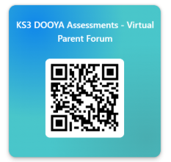

https://forms.office.com/e/WBYqaCd77z

Thank you, as always, for your continued support. By working closely together, we can help all our students achieve their very best.

Yours faithfully,
Luke Green
Associate Assistant Principal
Bristol Brunel Academy

